IBM (NALAIYA THIRAN)

ASSIGNMENT NO : 4
TEAM MEMBER : Narmatha U
TEAM ID: PNT2022TMID50604
REG NO :952819106017
EMAIL : narmatha.ug19.ec@scadengineering.ac.in

QUESTION:
1.Write Code and connections in wokwi for ultrasonic sensor. whatever
distance is less than 100 cm send “Alert” to ibm cloud and display in device
recent events.

CODE:
//Pins
const int TRIG_PIN = 7;
const int ECHO_PIN = 8;
//Anything over 400 cm (23200 us pulse) is "out of range"
const unsigned int MAX_DIST = 23200;
void setup() {
// The Trigger pin will tell the sensor to range find
Pin Mode(TRIG_PIN, OUTPUT);
digitalWrite(TRIG_PIN, LOW);
//Set Echo pin as input to measure the duration of
//pulses coming back from the distance sensor
pinMode(ECHO_PIN, INPUT ) ;
// We'll use the serial monitor to view the sensor output
Serial.begin(9600);
}
void loop() {
unsigned long t1;
unsigned long t2;
unsigned long pulse_width;
float cm;
float inches;
// Hold the trigger pin high for at least 10 us
digitalWrite(TRIG_PIN, HIGH);
delayMicroseconds(10);
digitalWrite(TRIG_PIN, LOW);
// Wait for pulse on echo pin
while (digitalRead( ECHO_PIN )==0 );
// Measure how long the echo pin was held high (pulse width)
// Note: the micros() counter will overflow after-70 min
t1= micros ();
while (digitalRead(ECHO_PIN) == 1);
t2= micros ();
pulse_width = t2-t1;
// Calculate distance in centimetres and inches. The constants
//are found in the datasheet, and calculated from the assumed speed
// of sound in air at sea level (- 340m/s)
cm=pulse_Width / 58 ;
inches = pulse_width/148.0;
// Print out results
if (pulse_width >MAX _ DIST ){
Serial.println("Out of range");
}
else {
Serial.println("*******************************”);
Serial.println("The Measured Distance in cm: ");
Serial.println(cm);
if( cm < 100 )
{
//while(true){
Serial.println(“Alert!!”);
//}
}
Serial.print(“***********************************”);
}
//wait at least 1000ms before next measurement
delay(1000);
}

OUTPUT:
Distance less than 100 cm
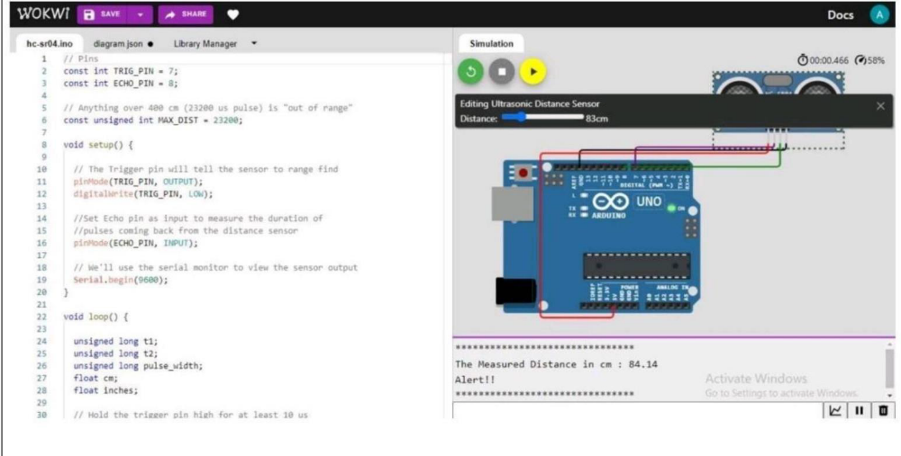
Distance more than 100 cm
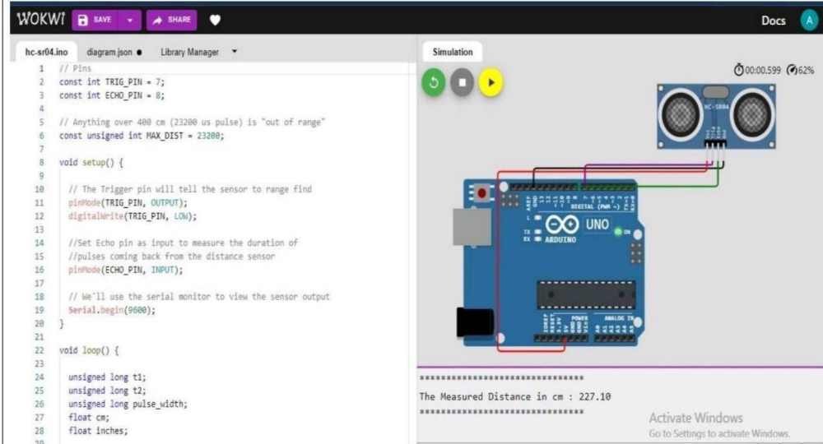m

